Course: High Performance Computing Lab

Practical No 1

PRN:22510079

Name: Vedprakash Patil

Batch: B3

Title: Introduction to OpenMP

Problem Statement 1 – Demonstrate Installation and Running of OpenMP code in C.

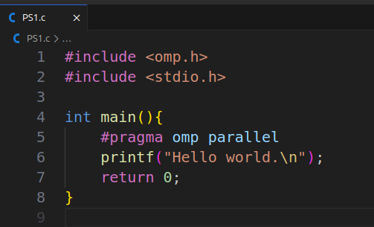

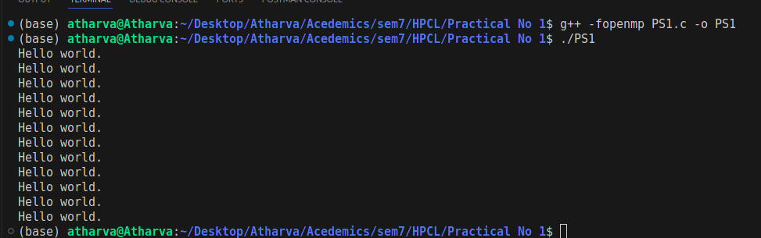

Problem Statement 2 – Print ‘Hello, World’ in Sequential and Parallel in OpenMP

We first ask the user for number of threads – OpenMP allows to set the threads at runtime. Then, we print the Hello, World in sequential – number of times of threads count and then run the code in parallel in each thread.

Code snapshot:

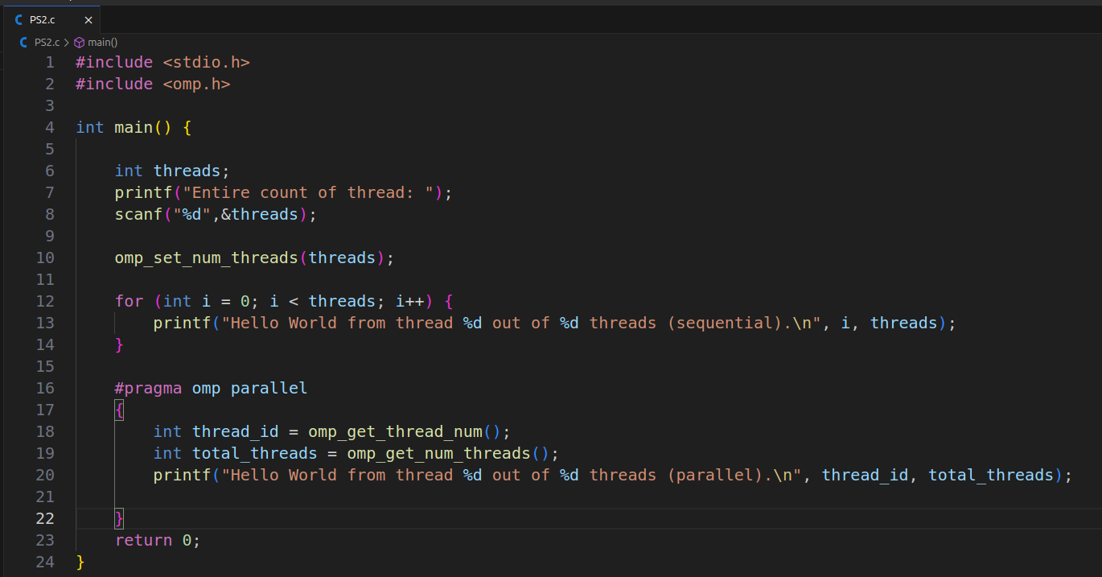

Output snapshot:

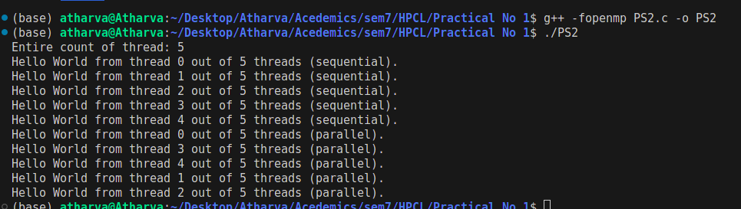

GitHub Link:

Problem statement 3: Calculate theoretical FLOPS of your system on which you are running the above codes.

Elaborate the parameters and show calculation.

* ***Clock speed = 4.5 GHz***
* ***core = 6***
* ***FLOPs per cycle = 9***

***FLOPS=8×3×109×9=238×109=238 GFLOPS***